BANK LOAN REPORT – QUERY DOCUMENT
- BANK LOAN REPORT | SUMMARY
KPI’s
Total Loan Applications
SELECT COUNT(Id) AS 'Total_loan_applications' FROM loandata;
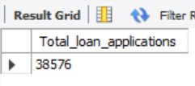
MTD Loan Applications
SELECT COUNT(*) AS MTD_Total_loan_applications FROM loandata
WHERE MONTH(Issue_Date) = 12 AND YEAR(Issue_Date) = 2021;
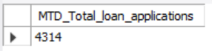
PMTD Loan Applications
SELECT COUNT(*) AS PMTD_Total_loan_applications FROM loandata
WHERE MONTH(Issue_Date) = 11 AND YEAR(Issue_Date) = 2021;
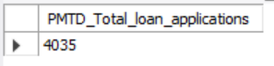

Total Funded Amount
SELECT SUM(Loan_Amount) AS 'Total_funded_amount' FROM loandata;
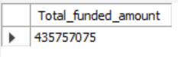

MTD Funded Amount
SELECT SUM(Loan_Amount) AS 'MTD_Total_funded_amount' FROM loandata
WHERE MONTH(Issue_Date) = 12 AND YEAR(Issue_Date) = 2021;
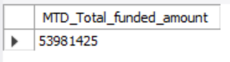

PMTD Funded Amount
SELECT SUM(Loan_Amount) AS 'PMTD_Total_funded_amount' FROM loandata
WHERE MONTH(Issue_Date) = 11 AND YEAR(Issue_Date) = 2021;
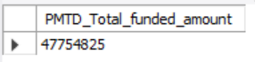

Total Amount Received
SELECT SUM(Total_Payment) AS 'Total_amount_recieved' FROM loandata;
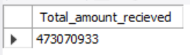

MTD Amount Received
SELECT SUM(Total_Payment) AS 'MTD_Total_amount_recieved' FROM loandata
WHERE MONTH(Issue_Date) = 12 AND YEAR(Issue_Date) = 2021;
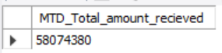

PMTD Amount Received
SELECT SUM(Total_Payment) AS 'PMTD_Total_amount_recieved' FROM loandata
WHERE MONTH(Issue_Date) = 11 AND YEAR(Issue_Date) = 2021;
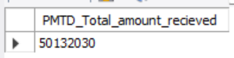

Average Interest Rate
SELECT ROUND((AVG(int_rate)*100),2) AS 'Avg_Interest_rate' FROM loandata;
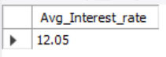

MTD Average Interest
SELECT ROUND((AVG(int_rate)*100),2) AS 'MTD_Avg_Interest_rate' FROM loandata
WHERE MONTH(Issue_Date) = 12 AND YEAR(Issue_Date) = 2021;
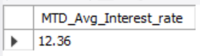

PMTD Average Interest
SELECT ROUND((AVG(int_rate)*100),2) AS 'PMTD_Avg_Interest_rate' FROM loandata
WHERE MONTH(Issue_Date) = 11 AND YEAR(Issue_Date) = 2021;
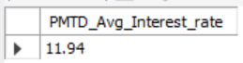

Total Debt-to-Income Ratio
SELECT ROUND(AVG(Dti),4) * 100 AS 'Avg_dti_ratio' FROM loandata;
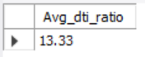

MTD Debt-to-Income Ratio
SELECT ROUND(AVG(Dti),4) * 100 AS 'MTD_Avg_dti_ratio' FROM loandata
WHERE MONTH(Issue_Date) = 12 AND YEAR(Issue_Date) = 2021;
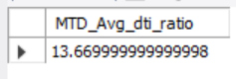

PMTD Debt-to-Income Ratio
SELECT ROUND(AVG(Dti),4) * 100 AS 'PMTD_Avg_dti_ratio' FROM loandata
WHERE MONTH(Issue_Date) = 11 AND YEAR(Issue_Date) = 2021;
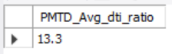

GOOD LOAN
Good Loan Percentage
SELECT
(COUNT(CASE WHEN Loan_Status IN ('Fully Paid', 'Current') THEN id END)
/
COUNT(id))*100 AS 'Good_loan_percentage'
FROM loandata;
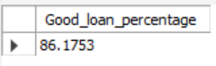

Good Loan Applications
SELECT COUNT(id) AS 'Good_Loan_Applications' FROM loandata
WHERE Loan_Status IN ('Fully Paid','Current');
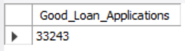

Good Loan Funded Amount
SELECT SUM(Loan_Amount) AS 'Good_loan_funded_amount' FROM loandata
WHERE Loan_Status IN ('Fully Paid','Current');
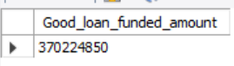

Good Loan Received Amount
SELECT SUM(Total_Payment) AS 'Good_loan_received_amount' FROM loandata
WHERE Loan_Status IN ('Fully Paid','Current');
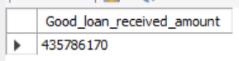

BAD LOAN
Bad Loan Percentage
SELECT
(COUNT(CASE WHEN Loan_Status = 'Charged Off' THEN id END) / COUNT(id)) * 100 AS 'Bad_loan_percentage'
FROM loandata;
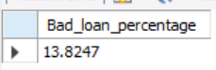

Bad Loan Applications
SELECT COUNT(id) AS 'Bad_loan_applications' FROM loandata
WHERE Loan_Status = 'Charged Off';
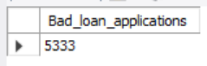

Bad Loan Funded Amount
SELECT SUM(Loan_Amount) AS 'Bad_loan_funded_amt' FROM loandata
WHERE Loan_Status = 'Charged Off';
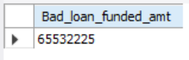

Bad Loan Received Amount
SELECT SUM(Total_Payment) AS 'Bad_loan_received_amt' FROM loandata
WHERE Loan_Status = 'Charged Off';
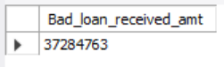

LOAN STATUS
SELECT
Loan_Status,
COUNT(id) AS 'Total_applications',
SUM(Loan_Amount) AS 'Total_Funded_amount',
SUM(Total_Payment) AS 'Total_Amount_received',
AVG(Int_Rate) * 100 AS 'Interest_rate',
AVG(Dti) * 100 AS 'DTI'
FROM loandata
GROUP BY Loan_Status;
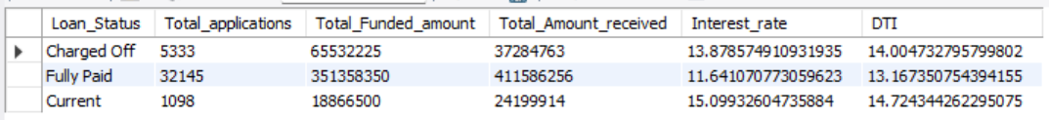

SELECT
Loan_Status,
SUM(Loan_Amount) AS 'MTD_Funded_amount',
SUM(Total_Payment) AS 'MTD_Amount_received'
FROM loandata
WHERE MONTH(Issue_Date) = 12 AND YEAR(Issue_Date) = 2021
GROUP BY Loan_Status;
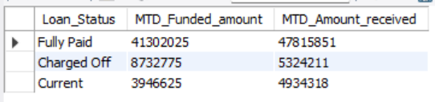

- BANK LOAN REPORT | OVERVIEW
MONTH
SELECT
MONTH(Issue_Date) AS 'Month_number',
MONTHNAME(Issue_Date) AS 'Month_name',
COUNT(id) AS 'Total_loan_applications',
SUM(Loan_Amount) AS 'Total_funded_amount',
SUM(Total_Payment) AS 'Total_received_amount'
FROM loandata
GROUP BY MONTH(Issue_Date), MONTHNAME(Issue_Date)
ORDER BY MONTH(Issue_Date);
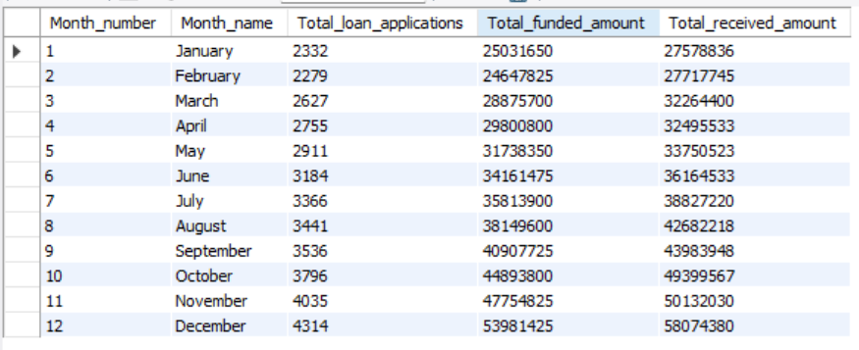

STATE
SELECT
Address_State,
COUNT(id) AS 'Total_applications',
SUM(Loan_Amount) AS 'Total_funded_amount',
SUM(Total_Payment) AS 'Total_received_amount'
FROM loandata
GROUP BY Address_State
ORDER BY Address_State;
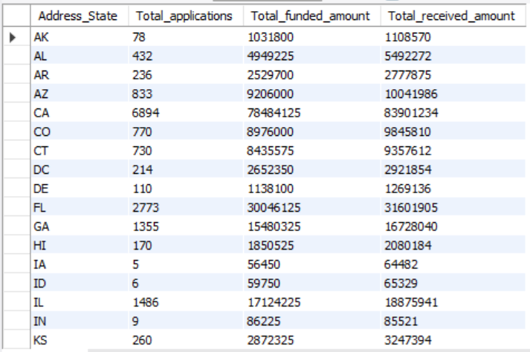

TERM
SELECT
Term,
COUNT(id) AS 'Total_applications',
SUM(Loan_Amount) AS 'Total_Funded_Amount',
SUM(Total_Payment) AS 'Total_received_amount'
FROM loandata
GROUP BY term
ORDER BY term;
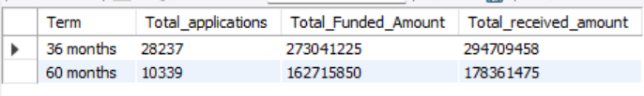

EMPLOYEE LENGTH
SELECT
Emp_Length,
COUNT(id) AS 'Total_Applications',
SUM(Loan_Amount) AS 'Total_Funded_amount',
SUM(Total_Payment) AS 'Total_received_amount'
FROM loandata
GROUP BY Emp_Length
ORDER BY Emp_Length;
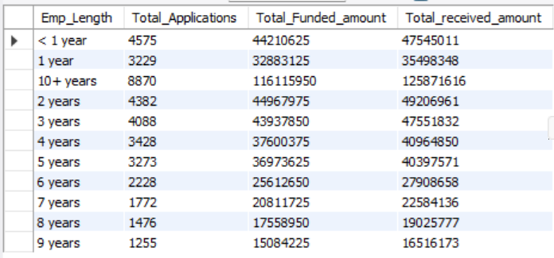

PURPOSE
SELECT
Purpose,
COUNT(id) AS 'Total_Applications',
SUM(Loan_Amount) AS 'Total_Funded_amount',
SUM(Total_Payment) AS 'Total_received_amount'
FROM loandata
GROUP BY Purpose
ORDER BY Purpose;
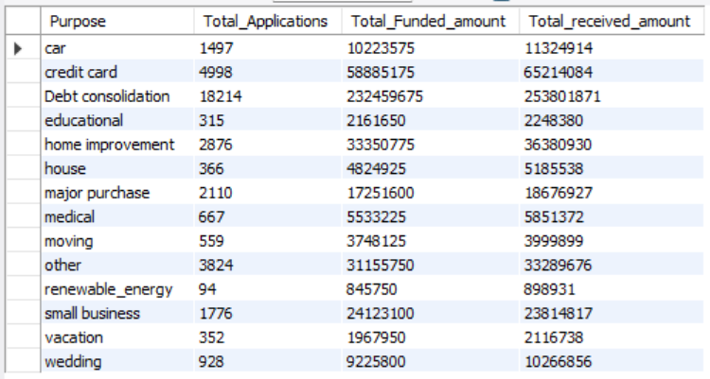

HOME OWNERSHIP
SELECT
Home_Ownership,
COUNT(id) AS 'Total_Applications',
SUM(Loan_Amount) AS 'Total_Funded_amount',
SUM(Total_Payment) AS 'Total_received_amount'
FROM loandata
GROUP BY Home_Ownership
ORDER BY Home_Ownership;
